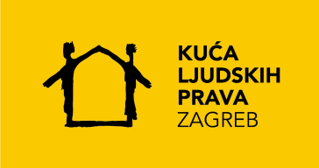 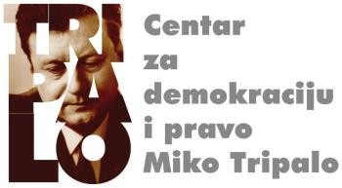

# *The situation in the Croatian judiciary*

# *Report on the rule of law - how to proceed?*

**Tuesday, September 10, 2024, at 10:00 a.m**

**House of Europe, Ul. Augusta Cesarca 4, Zagreb**

# PROGRAM

10:00 – 10:15 *Greeting*

**Tvrtko Jakovina, Centre for Democracy and Law Miko Tripalo**

**Ivan Novosel, House of Human Rights Zagreb**

**Hristo Hristov, Representation of the European Commission in Croatia**

**H.E. Arne Sannes Bjørnstad, Embassy of the Kingdom of Norway in the Republic of Croatia**

10:15 – 10:30 Presentation of public opinion research on the judiciary

**Neven Mates**, Centre Miko Tripalo

10:30 – 10:45 *Presentation of the Report on the Rule of Law for 2024.*

**Jože Štrus**, European Commission, online

10:45 – 12:30 Round table on the state of the judiciary and the Report on the rule of law

**Radovan Dobronić,** President of the Supreme Court of the Republic of Croatia

**Zlata Đurđević,** Faculty of Law in Zagreb and Miko Tripalo Centre

**Neven Mates,** Centre Miko Tripalo

**Ivan Novosel,** House of Human Rights

**Tena Šimonović Einwalter,** Ombudsman

**Alan Uzelac,** Faculty of Law in Zagreb and the Miko Tripalo Centre

**Representative,** Ministry of Justice and TBC Administration

12:30 – 12:35 *Final words*

The meeting will be moderated by Vedran Đulabić, the Miko Tripalo Centre and the Faculty of Law in Zagreb.

